Title: | The Legends of Olympus |  |  | Time: | 45 minutes
Subject: |  |  |  | Languages, Social Studies
Aims: |  |  | General competence: 3. Receiving written messages in different communication contexts.  Specific competence: 3.1. Selecting detailed information from informative or literary texts.  Aim of the activity: using computational thinking to understand, analyse and summarise a story.
Key CS elements: |  |  | Decomposition; Pattern recognition; Abstraction; Algorithm design.
Age group: |  |  | 10-12 years old
Learning situations: |  | classroom, IT lab |  | Activity type: |  | analysis
Resources: |  |  | computer, workspace
Learning development:
Problem definition: The achievement of the 12 labors of Hercules
1.Decomposition: we divide the problem into smaller, more manageable segments
Over time there have been several tasks. The most important were:
- Slaying the Nemean Lion
- Slaying the Lernaean Hydra
- Capturing the Ceryneian Hind
- Capturing the Erymanthian Boar
- Killing the Stymphalian Birds
- Capturing the Cretan Bull
- Steal the Mares of Diomedes
- Stealing the girdle of the queen of the Amazons, Hippolyta
- Stealing the cattle of the monster Geryon
- Stealing the Hesperidean Apples
- Capturing Cerberus, guardian of the Underworld
2. Pattern Recognition:
The legends of Hercules are events that have elements in common, as they fall into the same category:
a) Definition:- The legends of Hercules describe the events in the life of Heracles, the son of Zeus and Queen Alcmene.
b) Shared causes:
-the death of his family in a moment of dementia
-Hercules's execution, which Hercules carries out as punishment
c) Shared events:
- they have a generic character, they are not limited to just one topic, the events are not told according to a unique plan
- killing monsters repeatedly
- the carrying out of Eristeu's order
- the impulsive character of Heracles
-the presence of gods and other creatures
d) The starting point: the whole story started from Zeus' affair with the mundane queen, Alcmene

3. Abstraction: making a mind map that will filter out unnecessary information
https://web.mindonmap.com/view/37855782198fd55f

4. Algorithm design We can quickly and easily recognize the beginnings of a narrative story, legend
-almost every legend is fictional, the stories presented are not based on real world events
-the characters in a legend have supernatural features, exaggerated by the author for a stronger impact on the reader
-the presence of gods and supernatural creatures
-presence of a subjective or objective narrator
-a legend text is written in prose

The steps needed to write a legend:
Step 1. Paying attention to the narrative flow.
Step 2. Understanding the plot and characters.
Step 3. Students understand the meaning of a legend and can identify one the legend.

Assessment: Monitoring the students
Expected results: students know the meaning of a legend and can identify one
Note: A legend is a narrative work written in prose, the author tending to exaggerate the events in order to create a stronger impact on the reader. The characters, often human beings or deities, venture into a series of battles.

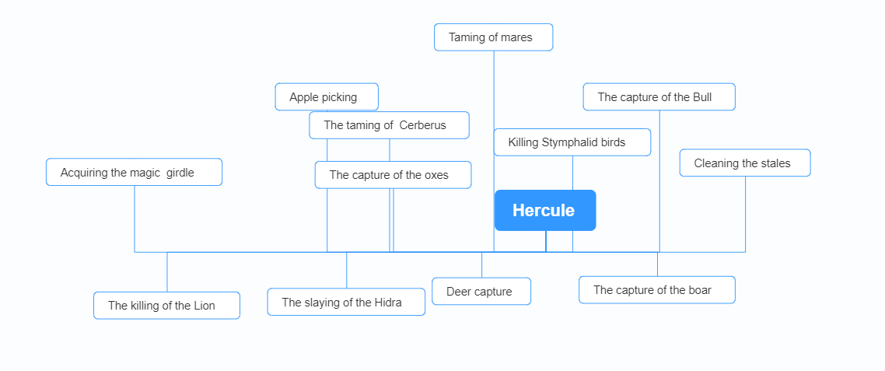

According to the school syllabus for visual Romanian language and literature, grades III and IV, approved by order of the Minister of National Education, no. 5003/02.12.2014
Idem

