Title | Sewing points |  | Time | 2 hours
Subject: |  |  | Art
Aims |  |  | General competence: 2. Making functional and/or aesthetic creations using various elementary materials and techniques  Specific competence: 2.3. Making useful and/or aesthetic products combining easy-to-work materials and accessible techniques  Aim of the activity: To discover and practise sewing stitches used in traditional art: the line, the fir-tree (brăduțul), the cross (musca). Building repetitive patterns with these stitching marks.
Key CS elements: |  |  | Decomposition; Pattern recognition; Algorithm design; Debugging;
Age group : |  |  | 8-10 years
Learning situations: | classrooms |  | Activity type : | curricular
Resources : |  |  | Video projector, offline
Learning development:
Problem definition:
How to make a bookmark using sewing marks from the local traditional art.
I. Decomposition:
1. The teacher shows two bookmarks with sewing marks on both cardboard and canvas (etamina).
2. Ask the students to say how they think they were created. They will discover that they need to punch holes in the cardboard/canvas at certain points and that they need to follow a pattern (working rule).
3. The teacher tells them that useful objects, such as bookmarks and other objects made of cardboard or cloth, tanned animal skin, can be decorated by stitching, and that for this, each object maker needs a working plan, in order to obtain a product the way they want it:
First, he will get a template: https://adlm.ro/product/semn-de-carte-motive-traditionale/#lightbox
or he will make a template himself with dots marked with crayon at equal distances:
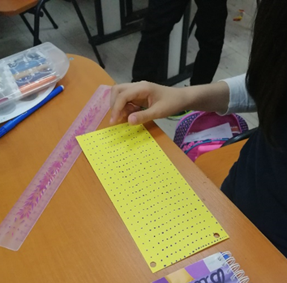
Then, with needle and thread, he will pierce the cardboard at two successive points so that a line is formed above the cardboard. Depending on the direction of the line and the sequence of perforations, we obtain different stitches (learning by discovery method):
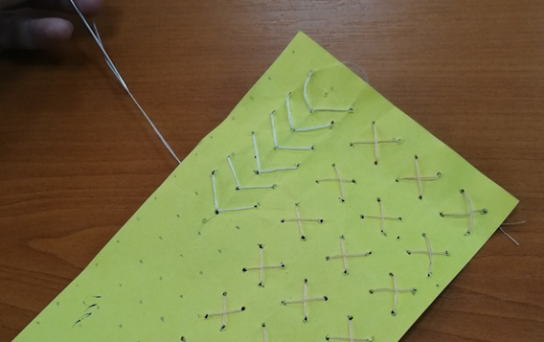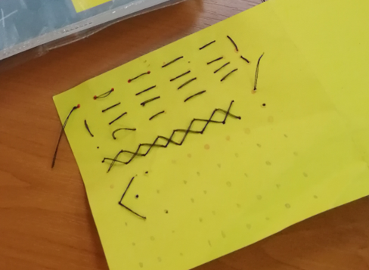
II. Pattern Recognition:
Through the succession of stitches, we obtain repetitive, decorative patterns that are used in traditional art:
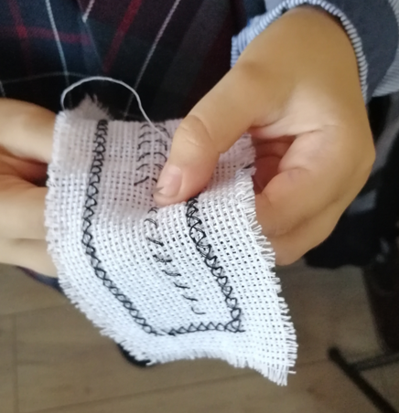
III. Algorithm design:
The student can create simple sequences:
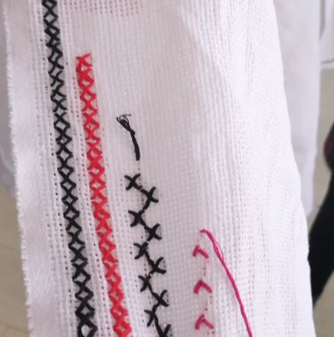
IV. Debugging.
The pupil quickly learns that errors can happen: wrong direction of the line obtained or wrong length of the line, unequal distances between the points in the repetitive pattern followed. The pupil may frequently encounter errors and learns that he has to find the point where he made a mistake, take the thread out of the needle, learn how to unthread by pulling the thread backwards, undoing the steps made to the wrong point, then mentally create the correct algorithm and start sewing again.
Practising the steps in the sewing algorithm cultivates perseverance, reduces the number of errors and increases the quality of the product obtained: a bookmark on cardboard or on canvas.
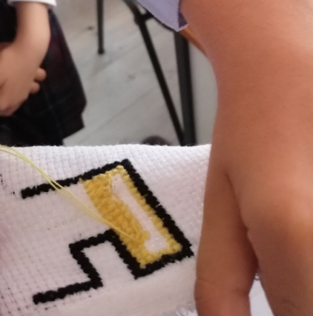
Assessment: |  |  | Monitoring students’ activity
Expected results: |  |  | Students can recognise the stitches on other creations and create a small functional product with these stitches.
Notes: |  | The lesson topic will be continued the next school year, when students will learn to transfer a repeating pattern to a grid of points and create a meaningful pattern on paper.

According to the school curriculum for ‘Visual arts and practical skills”, preparatory grade, grade I and grade II, approved by order of the Minister of Education no 3418/19.03.2013
Idem
Source: https://talentedenazdravani.eu/concursul-flori-de-mai-27-3/andreea-ecaterina-t3/#main
Source: https://www.invietraditia.ro/semn-de-carte-cusut-manual-cu-motive-traditionale-romanesti-model-1/

