Title | Traditional Romanian women's shirt (Ia) | Time | 2 hours
Subjects: |  | History, Art
Aims |  | General competences:  3. Demonstrate civic behaviour by valuing historical experience and socio-cultural diversity  4. Autonomous and responsible use of tools for lifelong learning  General competences:  3. Expressing ideas, feelings and messages, using artistic-visual language in a variety of contexts  Specific competences:  3.1. Exploiting historical experiences provided by the action of personalities/groups in different historical contexts  4.2. Initiating, developing and implementing individual and group projects drawing on diverse historical experiences  Specific competences:  3.1 Explore alternative ways of expressing ideas, feelings and messages in different artistic fields  Aims of the activity: Understand how ”ia” (the traditional Romanian women's shirt) is made by applying the four principles of computational thinking.  Understand conditional if and if/else statements;  Divide a complex task into a sequence of simpler actions,  Recognising authentic sequences;
Key CS elements: |  | Decomposition; Pattern recognition; Abstraction; Algorithm design;
Age group : |  | 14-16 years old
Learning situations: | classrooms | Activity type : | extracurricular
Resources: |  | Video projector, internet access
Learning development:

Problem definition:
•We introduce the students into the topic explaining how the traditional Romanian shirt for women, ia, is made, to be able to establish its authenticity and to understand its symbols.
•We discuss the cultural value of ia
Nothing can better describe the history and specificity of a culture than the traditional costume. Ia is the basic piece of the traditional women's costume. The wordie is attributed only to traditional women's shirts.
From an etymological point of view, the word ie, attributed to the traditional shirt of the Romanian costume, is derived from the Latin tunicae lineae, which means the thin tunic worn on the skin. Its story begins during the Cucuteni culture, the oldest civilization in Europe, which lived between 5,200 and 3,200 BC, on the current territory of Moldova, northeastern Muntenia, southeastern Transylvania and Bessarabia.The craft of making ia has lasted over time because it has been passed from generation to generation.The Romanian ia is a broad and complex code of symbols, which briefly tells the story of the individual bearer, but also of the communityhe comes from. A code that uses simple means-tailoring, material, colors, embroidered symbols - and says a lot in a little. Without seeing the wearer, but only the garment, we can find out, immediately, everything about him: ethnicity, sex, age, marital status, place of origin, destination of the garment (work, celebration, wedding etc).
The other elements of the traditional costume are extremely pleasantly outlined around ia.All together, in a chromatic and ornamental harmony, they make up the uniqueness of the Romanian folk costume. For Romanians, the traditionalia is and must remain, a national symbol, an element that highlights our history, present, permanence and continuity, but also a characteristic of our cultural future. After the Great Union of 1918, ia was promoted as a unitary symbol of Romanians, the folk costume being similar in all areas around the country. Preserving, until nowadays, both archaic tailoring systems and ancient ornamental motifs, the shirt has best preserved the features of our ancient specificity.
The Romanian costume, implicitly, has two essential characteristics: its unity and continuity. Through continuity we understand the path traveled by the folk costume born on the ancient hearth of the Dacian civilization, to this day. Through unity we must understand those features, those essential aspects that can be seen in the Romanian costume throughout the country. Romania is divided into seven folk regions, each with its own specificity, but ia represents a unitary structure that contains essential features and aspects that can be noticed throughout the country.
The characteristics of the ia are given by the sewing patter(the shoulder part, which joins the front and back of the sleeve), ‘încrețul’, the crease (it emerged for practical reasons: in the past the elastic was not invented, and the încreț had a similar role, linking the narrower part (altița) with the rest of the sleeve, which was wider to be more comfortable), ‘altita’(the wide band, the defining and unique element of the pattern), the ‘rivers’ (straight or oblique strips on the chest and sleeves) and‘bibiluri’, the wrenches (the sewings joining fabric pieces). Another feature of the women's costume is the use of color, the background of the fabrics (linen, hemp, cotton, silk, or wool) is white.
Therefore, we aim to reconstruct the traditional Romanian shirt for women, so that it can be recognised by students.
So, if we see an ia, then, can we recognize its authenticity or else, can we determine its destination?

I. Decomposition:
1.Composition of an ia:
- The shoulder – the sewing that connects the sleeve to the material that represents the front and back of the shirt;
- ‘Încrețul’ – the way the sleeve wrinkles, in the absence of the elastic part;
- Altița – wide band and rich in various decorations on the sleeve; this is also the main element of an ia;
- Strips on the sleeves and chest – which can be straight or oblique, also called „ rivers”;
- Bibiluri (connection parts) – the strip that binds the fabric.
- The back- which is not embroidered.

2.The element to be considered for determining the typology is the tailoring (Annex 1):
Depending on how the front and the backparts are made, as well as how the sleeves are connected to them - from the shoulder or neck, we distinguish in the Romanian folk costume, two fundamental types of shirts: the straight and the wrinkled shirt, each with its variants. These two types coexisted throughout Romania, their frequency varying from one area to another.
- The straight shirt belongs to the original cultural background of humanity, having the tunicas a prototype, it was attested by the archaeological testimonies on the territory of Central Europe since the Bronze Age. Known to us, but also on the right side of the Prut river, under the name of ‘old shirt’, the straight shirt presents, throught Romania, a great morphological and stylistic unit, which is conferred both by the raw materials from which it is made - hemp, linen, cotton, borangic (silk) - the differentways of association of the fibers used, the elements of the cut and the terminology related to them, as well as the decorations. The sleeves were either loose at the lower end or clenched on bracelets in the shape of two-fingered wide straps, astened with buttons, or brimmed with ruffles. The straight shirt was originally without a collar, crooked around the neck, and later with a narrow collar like a headband.
- The shirt wrinkled around the neck, known as a Carpathian type, is a ceremonial shirt, thus being richlydecorated. It is wornin the entire area inhabited by Romanians, except for Maramureş, Dobrogea and the eastern Bărăgan regions. The sleeves were either wide, free at the lower end, or tightened with a thread, through a crease similar to the neck opening one, joined in a band or brimmed with ruffles. The ia with a round neck, tightened with a string, comes from the Dacians, Romanian ancestors. Ia is typical only to Romanians. The Dacians were dressed in shirts wrinkled around the neck, long and loose, and the ceremonial ones also had embroidery.
3. Adornment/Embrodery :
a) abstract symbols: cosmic, zoomorphic, and anthropomorphic
b) realistic floral and vegetable symbols (plants, leaves, flowers, fruits)
c) geometric and abstract symbols
4. Chromatic:
The colors with which the seams of ia are realized have a special meaning. The following colors are generally used: red, blue, yellow, green, orange, violet and black.

II. Pattern Recognition:
The Romanian traditional costume is apparently different from one area to another, but it has kept a unitary structure in terms of the following elements:
  - Raw material: hemp, linen, cotton and `borangic` (traditional Romanian silk). (Annexes 2,3,4,5, 6). The straight shirt made of hemp or cotton, was worn on working days. It was not decorated.
  - The fabric from which it is made is always white.
  - Tailoring: the traditional shirt never has short sleeves.
  - The opening of the shirt: the authentic ia is always gathered tightly around the neck, either for a sober outfit, but also for practical reasons.
  - The essential pattern. (Annex 7,8) The mandatory elements of the ia are altița, the crease and the ‘rivers’ on the sleeves and on the front part.
If these components are missing then it is not an ia, otherwise you can call it a stylized blouse with traditional motifs.
‘Altița’ is the wider side of the shoulder, which is organized in several registers, in horizontal lines. The crease is the functional part. At the beginning, when the shirt was washed, ‘altița’could be detached, because it was embroidered with expensive metal thread. Currently, the crease is decorative because it no longer has the former purpose. The third important element is the ‘rivers’ the swing pattern that can be vertical or oblique. At the front, the ‘rivers’ are embroidered according to the desired ornament. The traditional motifs on the sleeves and the front part may be different, but they should follow the main topic. The whole design must be organized symmetrically: ‘altița’ should be10-11 centimeters wide and 18 centimeters high. The ‘crease’ covers 3-4 centimeters. ‘Altița’and the ‘crease’ should cover 1/3 of the length of the sleeve, while the remaining part is designated to the ‘rivers’. There are no proportions for the front part, but embroidery starts just below the neck opening.
  - Adornment / embroidery:
The distinguishing elements of the Romanian sewing pattern reside in a balanced alternation of the embroidered and unembroidered parts. The embroidery of an authentic ia is always handmade, using ‘borangic’ (thick, silk thread) or natural cotton yarn (‘arnici’).
The ornamental motifs are placed on the sleeves (‘altița’, the wrinkled part, the ‘rivers’), on the front (on one side and the other of the shirt), on the back and on the lap.
These symbols are considered as mere protectors of those who wear the traditional shirts, keeping evil and bad luck away. In general, the same symbols mentioned above can be found throughout Romania. So, knowing these symbols we can decode the symbolism of the shirt or, otherwise, we can establish its authenticity.

The cosmic symbols( Annex 9 ) of traditional folk costumes are:
•solar symbols: the Sun (sunflower) or stylized circle
• the lightning
•the stars
•the Moon
•Milky Way
The Zoomorphing symbols:
•the horns and theforehead of the ox
•the sparrow
•the pigeon
•the roosters
•the swallow
•the hen
Floral and vegetable symbols (Annex 10):
•the wheat spikes
•the acorn
•the cobs
•the blueberry
•the grapes
•the apple
•the hair
•the rose
•the tulip
•the lily or cherry flower
The tree and its branches are symbols of resurrection and wisdom. The Romanian market are often represented as stylized forms of spirals flower and leaves, (with reference to vine or pumpkin cloths), represented with green, purple or blue thread
Anthropomorphic symbols:
• women’s silhouettes
•parts of the human body: the eye
The geometric symbols (Annex 11) are related to the imaginary world and the old beliefs of the Romanian peasants. Here the symbols are:
•diamonds
•squares
•circles: cyclicality
•snails (stylized spirals ) = magic
•crosses = spirit and evolution
•eyes
•string = thread of life
•straight lines = the right path in life
Among the symbols often used we find the spiral and the right spiral, the cross, the sun, the deer antlers, the straight lines, the straight double lines, the curved lines, the wheel, the rhombus, the spiral, the tree, or branches, each of them having special meanings. The spiral represents eternity, the passage of time, a universal sign of its life and permanence, of energy. This symbol has been used since the Cucuteni culture period. The source of life is rendered by spiral, a symbol of fertility. It can also be a dual, masculine-feminine sign, dark-light etc. The cross represents man's faith in God, the very cut taking the form of the cross. Horizontal straight lines suggest death, the interruption of a stage of human life, while vertical straight lines, life. The lightly wavy lines send us with the thought of water, the cleanliness and purification it brings, and the tree or branches symbolize the permanence and sustainable life, the rebirth year after year.
Another interesting thing about the composition of the shirts is that the pattern in the top, i.e. the sky, cannot be repeated elsewhere and therefore each part of the structure must contain a different pattern.

  - Chromatic:
The colors with which the seams of ia are realized have a special meaning. Nothing was left to chance in the process of creating a traditional one. Each woman carefully chose her mysterious colors and symbols to highlight and carry as far as possible the essence of the message that would be transposed into the pattern of embroidery. The girls and young girls wore bright colors like lemon yellow, orange, purple, good married girls wore green, newlyweds wore them sewn in red, mothers wore light blue, while widows and elderly women wore dark blue, black, or brown. The colours had different meanings for the community: black ornaments announced the death of a loved one, and embroidery with bright colors symbolized virginity or were specific to certain ceremonies: weddings, baptisms, religious holidays.
RED
Red symbolizes life, love, passion, fire. Therefore, traditional yyns embroidered with this color were intended to be worn especially by young women, recently married. The energy and heat released by the red color, such as fire, were meant to signify life-giving power, vitality, and love.
BLUE
Unlike young wives, who wore red ones, women who became mothers dressed especially with them sewn in blue. Predominant in Muntenia, this color symbolizes water, creative energy and is represented by geometric shapes such as spiral and circle. Through the soothing force, shades of blue as well as those of silver transmit spiritual energy, depth, stability and hope to the one who wears this embroidery.

YELLOW
Solar energy, joy and warmth are rendered by this color, a symbol of the richness of the earth and of the fruitfulness, of the life-giving star and of the golden ears. Traditional yellow embroidered sheep were dressed especially by young, unmarried girls who proudly wore cheerful embroidery in bright colors on Sundays to the village choir. The warm colors, golden and ocher, were most common in the southern part of the country and were represented by geometric signs in the form of spikes, spiral or circle.
GREEN
Prosperity and vitality are represented by this color of nature, a symbol of youth, joy, and spring. Perhaps that is why raw green is most often worn by children, in combination with pastel shades of straw yellow, blue, pink, or lilac. Emerald green is more common in Moldova, in combination with other vivid colors, such as orange, bright red or intense blue, specific to floral or geometric embroidery worn by girls only good to marry.
ORANGE
A vibrant, hot, healthy color, orange symbolizes energy, vitality, adventure, and good health. The embroidery in this color was proudly clothed by young girls.
VIOLET
Violet is the color of obedience, obedience, a symbol of autumn and fruitfulness of the Earth, found especially on the embroidery of Salaj or ŢaraOașului regions. Darker tones were worn by older women, along with cherry, brick or brown, while light, lilac or purple shades appeared in combination with other pastel colors, on the days of unmarried girls or young women.
BLACK
In the past, embroidery sewn with black, dark blue or brown thread was worn by old women and with a certain social status, as a symbol of sobriety, wisdom, and decency. This type of embroidery was specific to the sewn in the Banat area, where there is a predilection for sober colors: brown, cherry, black, dark green.
If we know the meaning of the colors, then, we will also know information about the recipient of the ia, otherwise it will seem a simple color.
If only one of the items noted above is missing, then ia is not authentic.
III. Abstraction:
- Making a mental map to remove unnecessary details. In order to recognize the authenticity of a ia we must take into account several elements. Each element sends a message about the person who wears it: ethnicity, social status, age, destination of the shirt.
We underline the fact that ”ia” is in fact a visual document taken into account by historians to reconstruct the ways of life in the Romanian area.
https://web.mindonmap.com/view/932ffcf56d90d304 Password：9050
- We will draw up a table in which we note the differences between a genuine and an imitation (handmade) ”ia” . This table will help students to distinguish more easily between a genuine and an imitation. A possible model table is attached in Annex 12.

IV. Algorithm design:

- The steps to follow to recognize the authentic ia are the following:
1.We check if the fabric is white and more robust.
2.We check if the cloth is made of natural materials, linen, hemp, cotton, borangic (traditional Romanian silk), wool. Even if they do not recognize the material exactly, students differentiate between a natural and a synthetic material.
3.We check if it has long sleeves. Unlike other peoples, the Romanian tradițional shirtwas never worn with short sleeves.
4.We check the presence of the obligatory elements of the ia: altița, the crease (încrețul) and the rivers (râurile) on the sleeves and rivers on the chest.
5.We check if it presents rich, specific ornamental motifs, sewn manually. An authentic ia even has ten types of embroidery. A hand-sewn ie differs from a sewn machine product. The traditional one has always been sewn by hand.
So if we have all these elements, the ia is authentic, otherwise it is just an imitation, or a shirt with traditional motifs.
https://web.mindonmap.com/view/848fd1302c2fd0fe
Password：3240
- Conclusion:
We emphasize to students the importance of ia in Romanian culture. They need to understand that ia is not a simple piece of clothing, but: Ia represents a CODE of national identity, a spiritual and cultural treasure of the Romanian people preserved throughout the ages. A code that uses basic means - tailoring, material, colours, embroidered symbols - and says a lot in a little. Without seeing the wearer, but only the garment, we can find out, at a glance, everything about him: age, marital status, place of origin, destination of the garment (work, celebration, wedding). The choice of motifs, the ornamental charge, the colour preferences also provide information about the worker's creativity and diligence. Each ia has its own energy provided by the person who designed it, with its own story.
Ia represents balance and perfection. The simpler the cut, the more profound its meaning. It represents the traditional shirt inherited from our ancestors, which is carefully worn from generation to generation to pass on and preserve as much of its symbolism and spiritual energy as possible.
It is a duty but also a privilege for each of us to know how to decode the traditional Romanian shirt, ia. Looking at this little piece of treasure loaded with meaning, you can't help but be proud to be Romanians.
Today, we wear ia to identify ourselves with the standard of beauty, goodness, and spiritual blissfulness.
- Application:
To design a project that will contain two parts:
1. The students of the 8th grade will have to carry out a group project consisting of taking photos of their grandparents' or parents' native area. These will be included in a video presentation which will also contain the story of the ia (how old it is, who sewed it, the meaning of the symbols). At the end of the project they will create a virtual album entitled IA AND THE JOY OF BEING ROMANIAN in which we will collect all the students’ pictures.
2. The pupils, organised in groups, will draw an ia, taking into account all the details discussed during the lesson (components, ornaments, colouring). The drawing will also contain a caption explaining the symbols of ia (ornaments and colours). The drawings will be included in the virtual album IA AND THE PRIDE OF BEING ROMANIAN.
The album will be posted on the Erasmus facebook page.
Assessment: |  | Monitoring the students’ responses and projects.
Expected results: |  | Students have the ability to recognize an authentic ia. They know the characteristics of a ia and can „ read ” the message it sends.
Bibliography:
Maria Bâtcă, Costumul popular românesc, Centrul Naţional pentru Conservarea şi Promovarea Culturii Tradiţionale, București, 2006;
https://historia.ro/sectiune/general/cariera-internationala-a-iei-camasa-traditionala-582878.html
https://www.ienationala.ro/blog/index.php/2021/03/03/motive-traditionale-romanesti-care-sunt-principalele-simboluri-si-care-este-semnificatica-lor/
https://mostenireculturala.com/2019/06/24/codul-secret-al-iei-traditionale/
https://www.invietraditia.ro/editorial/ia-romaneasca/
https://iiana.ro/blog/fashion/motive-populare-romanesti-principalele-modele-de-cusaturi-si-semnificatia-acestora/
https://mythologica.ro/ce-semnificatie-au-desenele-de-pe-costumele-populare-romanesti/
Notes:
- The importance of traditional ia, a symbol of national identity, is emphasized.
- The importance of the use of natural materials but also of the specific decor is emphasized.
- Using the mental map helps students to compress and view information more easily.
-With the help of the table (Appendix 12) students will be able to distinguish between an authentic and an imitation ia;
- The project will give pupils the chance to discover part of the Romanian cultural heritage.

Annex 1. The spread of the two types of ia in the Romanian historical space:
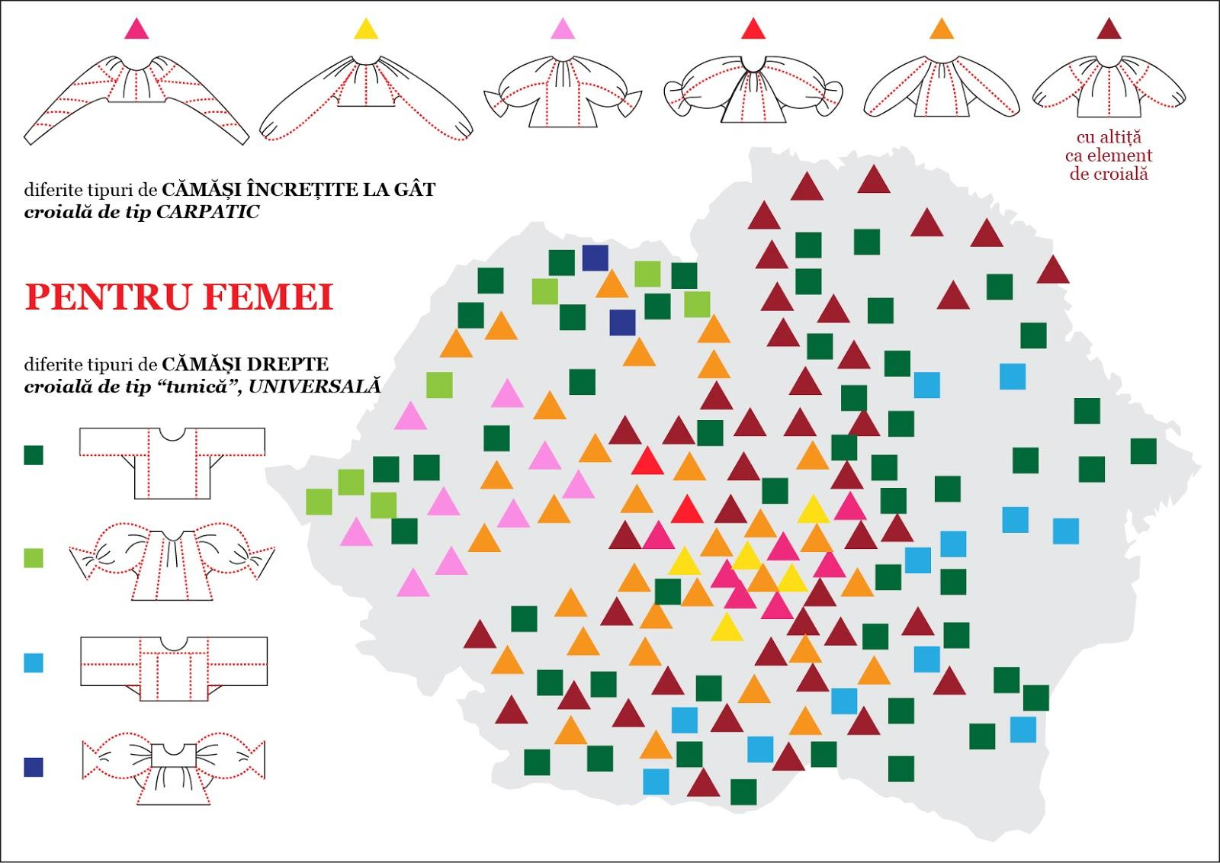

Annex 2. Hemp fabric:
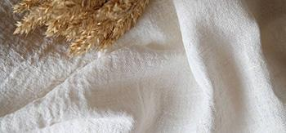
Annex 3. Linen fabric:
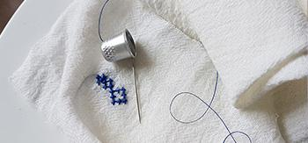
Annex 4. Cotton fabric:
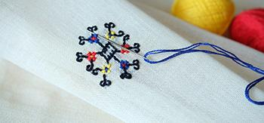
Annex 5. Borangic (thick silk fabric):
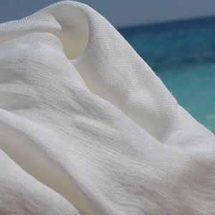
Annex 6. Wool fabric:
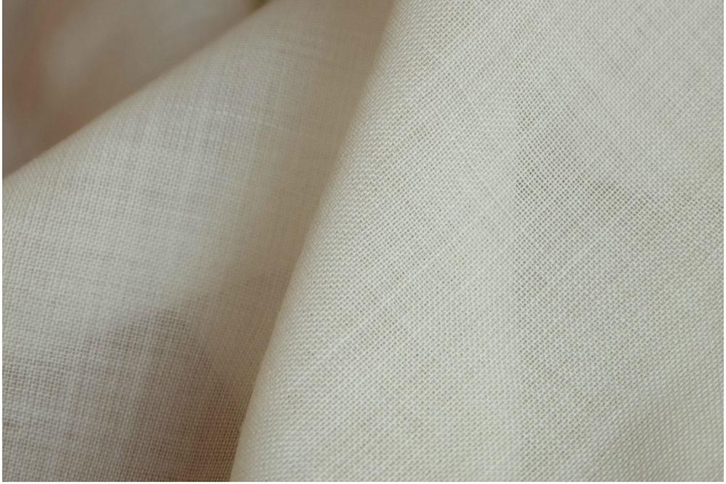

Annex 7. The tailoring pattern of an ia:
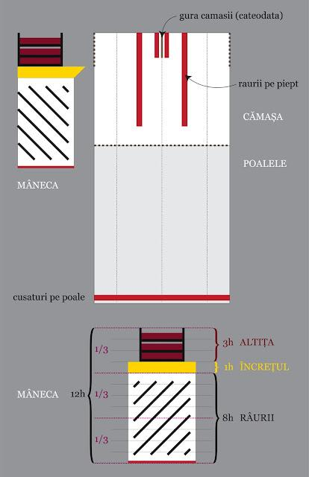
MÂNECA- SLEEVE
ALTIȚA-wide band and rich in various decorations on the sleeve
ÎNCREȚUL- the sleeve wrinkles, without the elastic;
RÂURI- Strips on the sleeves and chest – which can be straight or oblique, also called „ rivers”;

Annex 8. Patterns of ia with, Altiță, Încreț and Râuri:
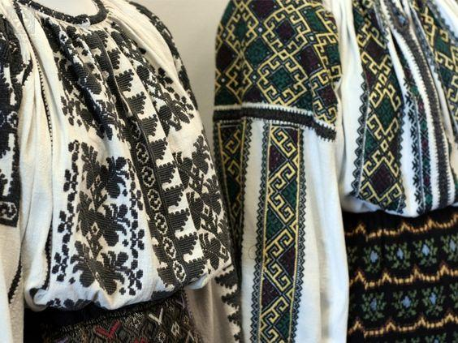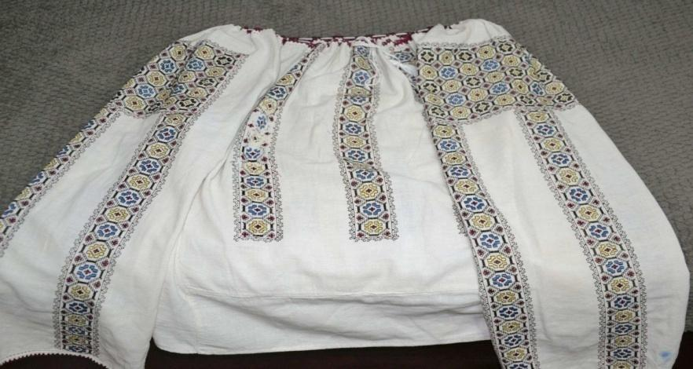
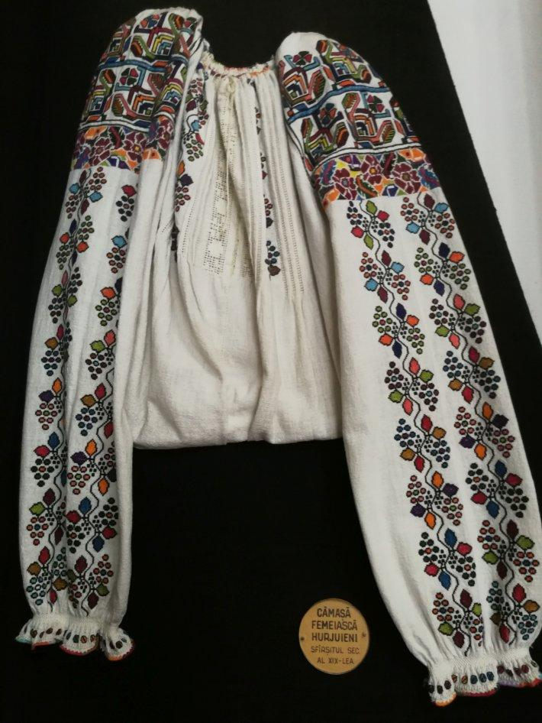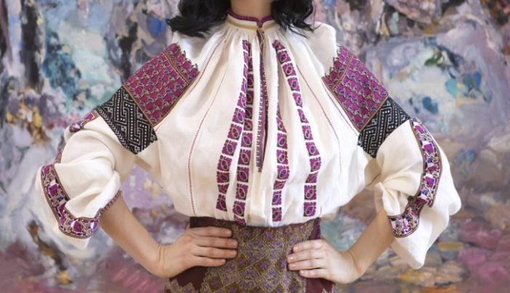
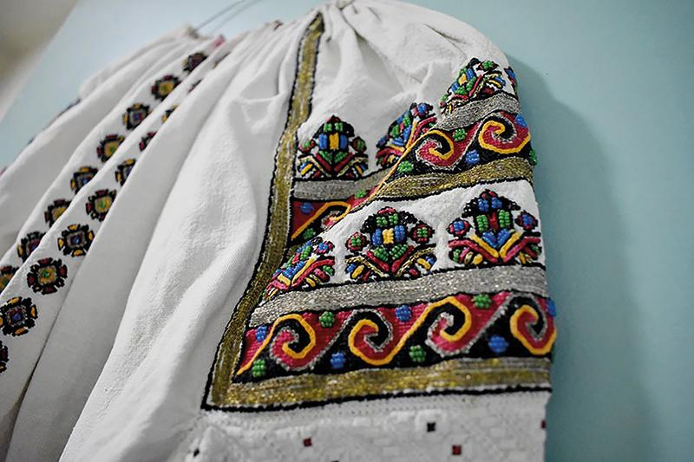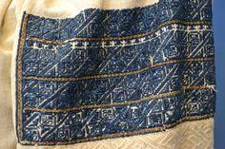

Annex 9: Cosmic abstract symbols:
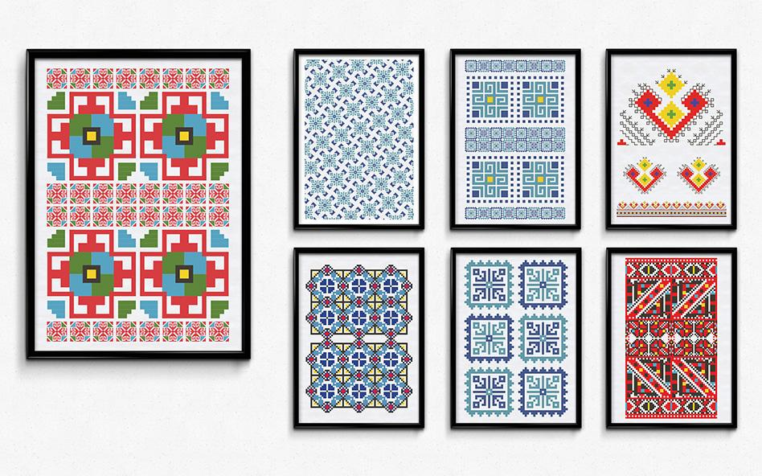

Annex 10: Floral or vegetable symbols:
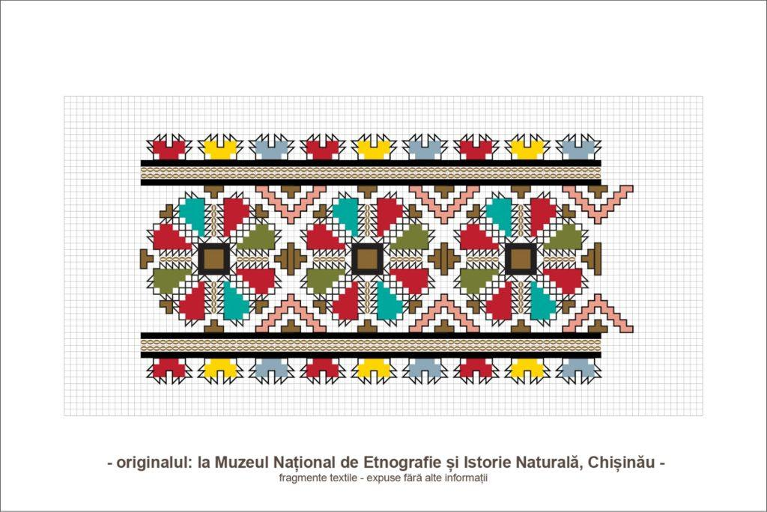
Annex 11: Stylized geometric symbols:
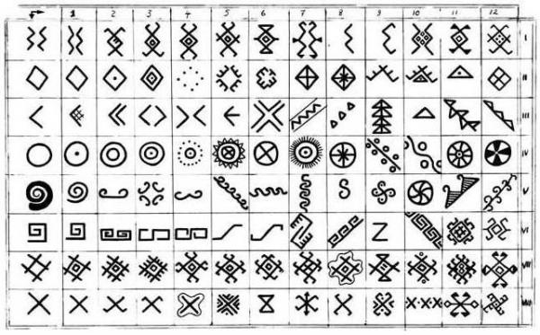

Anexa 12. Comparison between an authentic and imitation shirt
AUTHENTIC IA | IMITATION
1.Materials used:  - The cloth is made of natural material: linen, cotton, hemp, wool, silk.  - The canvas is more robust.  -The cloth is always white; | - Materials used:  - The fabric is made of synthetic material;  - The fabric is thin or even transparent.  - The fabric can have different colours;
- The tailoring:  - Ia is always long-sleeved; | - The tailoring  - Ia can also be short-sleeved;
- The neckline  - Ia is always gathered tightly around the neck to maintain a sober look; | - The neckline  - Ia is shaped at the neck with crochet laces or rare curls that make them fall on the shoulders;
- Sewing techniques  - Ia is always sewn by hand and you can find up to ten different types of embroidery stitched on it, on two threads of cloth; | - Sewing techniques  - Ia is machine-stitched and craft stitches are limited to simplified crosses or openwork;
- Ornaments  - Ia has a richly significant charge through its symbols, purposely sewn and placed in strict ornamental fields; | - Ornaments  - Simple floral or geometric elements repeated throughout;
- Colours  - Yarns in natural colours are used, harmoniously combined; | 6. Colours  - Brighter colors and artificial yarns are used;

According to the school curriculum for History, grade VIII, approved by order of the Minister of Education no. 3393 / 28.02.2017.
According to the school curriculum for Art Education, grade VIII, approved by order of the Minister of Education no.3393 / 28.02.2017.
Idem1
Idem2

