Title | Exploring Geography Through a School Trip |  | Time | 2 days
Subject: |  |  | Geography
Aims |  |  | General competence 4. Developing an interest in local knowledge, the country, and the contemporary world.  Specific competence 4.1. Stirring interest in geographical features of the local area, the country and the contemporary world.  Aims of the lesson:  • Engage students in active observation and exploration of geographical features during a school trip.  • Develop students' geographical awareness and understanding through hands-on experience.  • Foster teamwork and collaboration as students work in groups to record observations and create a final product.
Key CS elements: |  |  | Decomposition; Pattern recognition; Abstraction; Algorithm design;
Age group: |  |  | 10-12 years old
Learning situations: | trip |  | Activity type: | extracurricular
Resources: |  |  | Maps of the trip route and destination, notebooks or digital devices for recording observations, writing materials, cameras or smartphones for capturing images, local guides or experts for assistance during the trip
Learning development:
Problem definition:
- Planning a school trip with geographical objectives where children are actively involved in observation.
Pupils are organised into working groups. They will use tools to record observations and write a final product in groups. The following will be observed along the route: landforms, waters, human settlements, economic activities, communication routes. The teacher will act as a guide on the way and will be assisted by local guides at the visited sights.
I. Decomposition
- Introduce the concept of the school trip with geographical objectives.
- Break down the objectives into smaller components: landforms, waters, human settlements, economic activities, and communication routes:
- notice the elements of the natural environment listed above.
- take notes of the characteristic elements.
- Explain the roles and responsibilities of students in observing and documenting each component.
II. Pattern Recognition:
- Discuss common patterns or characteristics of each geographical component.
- Help students recognize the interconnectedness of different elements along the trip route.
- Encourage students to identify recurring themes or observations they may encounter.
For example: the natural environment determines the vegetation, vegetation influences the spread of animals, human activities favor the development of human settlements, the development of settlements leads to the development of communication routes.
III. Abstraction:
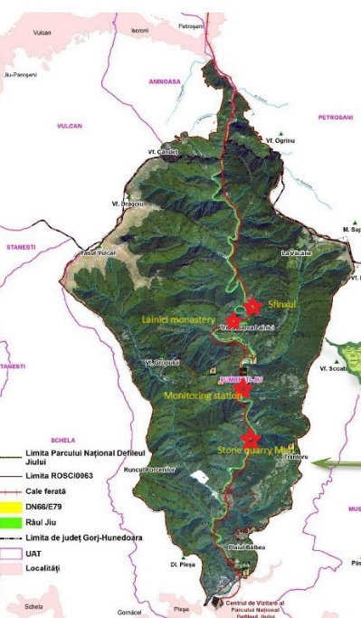
- Abstract key concepts related to geographical observation, such as identifying landmarks, analyzing patterns of human activity, and understanding the impact of geography on communities.
For example: - in the mountain area there are extensive forests where people are engaged in logging and wood processing, sheep farming and agro-tourism.
-As they are limestone mountains there are caves dug by water and people have opened stone pits. This stone is used for railway embankments and other pavements.
-From the riverbeds, river stone and sand are quarried; where the river flow is higher, water sports are practiced.
- Emphasize the importance of abstracting information to understand broader geographical principles.

IV. Algorithm Design:
- Provide students with a step-by-step plan for the school trip, outlining key observation points and activities along the route.
- Explain how students will be organized into working groups and assigned specific tasks for recording observations.
- Discuss the role of the teacher as a guide and the assistance provided by local guides at various sights visited:
Târgu Jiu-Bumbești Jiu (the teacher explains that they get into the Gorge of the river Jiu coming out of the Tg-Jiu Depression, at Bumbesti Jiu he explains that it is a transit town to the mountain area, then follows the Gorge where the places of interest are: the Natural Reserve of the Gorge of the river Jiu, the Meri stone quarry, Lainici Monastery, the Lainici Syphinx.
V. Implementation:
- Embark on the school trip, with students actively engaged in observing and documenting geographical features.
- Encourage students to use tools such as maps, notebooks, cameras, and smartphones to record their observations.
- Guide students in collaborating within their working groups and sharing their findings with each other.
VI. Reflection:
- After returning from the trip, facilitate a discussion on students' observations and experiences.
- Encourage students to reflect on what they learned and how their understanding of geography has evolved.
- Discuss any challenges encountered during the trip and brainstorm possible solutions for future excursions.

Assessment: |  |  | The participants will represent in linear form the route of the trip, marking the sights visited. They will create a slideshow with the most representative elements. They will add 2-3 descriptive lines to each slide.
Expected results: |  |  | The students can narrate events including information they have received from the trip and choose a new route for a following trip.
Notes: |  | It is an extracurricular activity that is suitable for any field research activity.

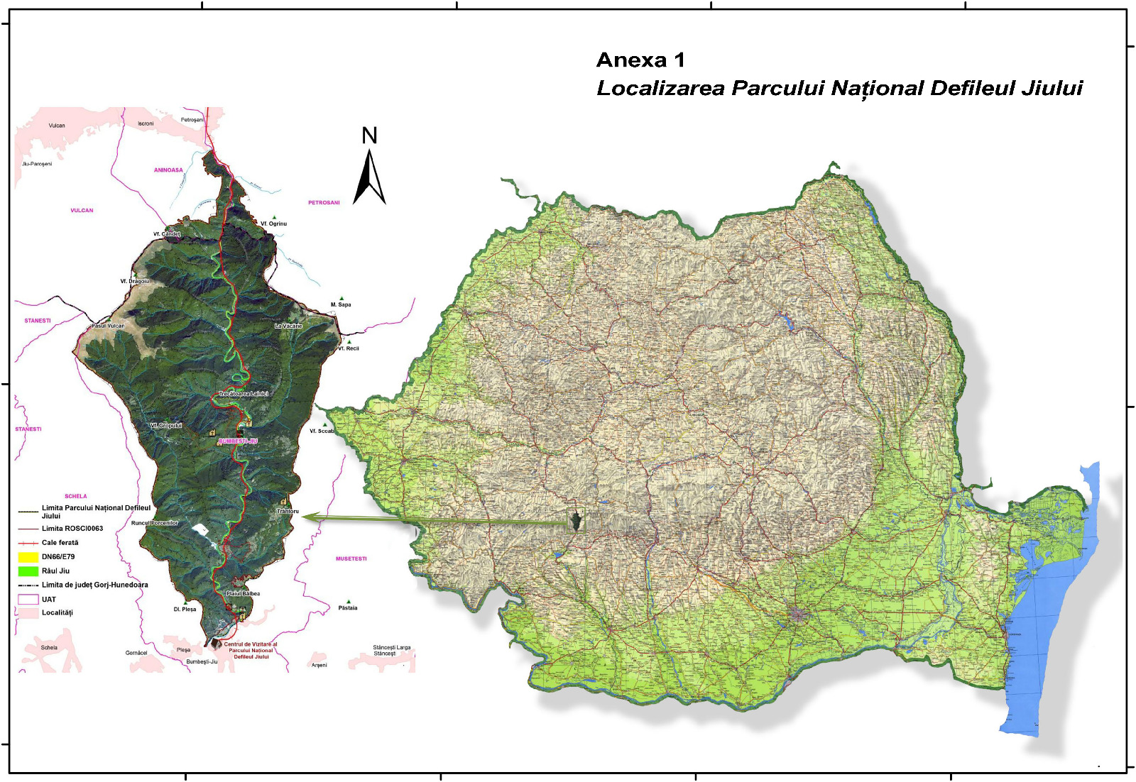

According to the school curriculum for Geography, grade IV, approved by order of the Minister of National Education, no. 5003/02.12.2014
Idem

