Title | A souvenir | Time | 2 hours
Subject: |  | Pendant with traditional decorative motifs
Aims |  | General competence 1. Making useful practical products and/or creative work for current activities and using them  Specific competence 1.1 Making useful and/or creative products through project-type activities, based on a technology sheet that the student draws up with the help of the teacher  Aim: Making an useful product using traditional art work techniques (sewn decorative patterns)
Key CS elements: |  | Decomposition; Pattern recognition; Abstraction; Algorithm design;
Age group: |  | 12-14 years old
Learning situations: | classrooms | Activity type: | curricular
Resources: |  | Video projector, offline
Learning development:
Problem definition:
We want to make a product, by sewing traditional motifs, that we wish to offer as a gift/souvenir.
II. Pattern Recognition:
1. What we could offer: a heart, a painting, a bookmark, which could support the sewing of a traditional decorative pattern.
2. What kind of material we could use: cardboard or etamine
3. What decorative pattern do we choose? We focus on the local art and explore some decorative art patterns:
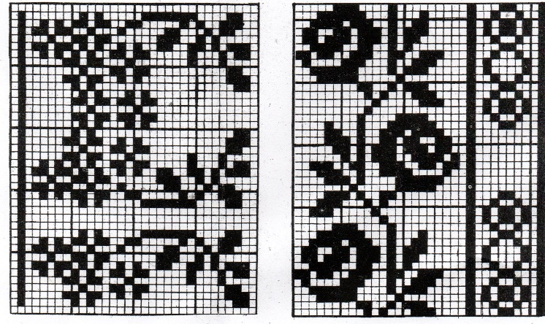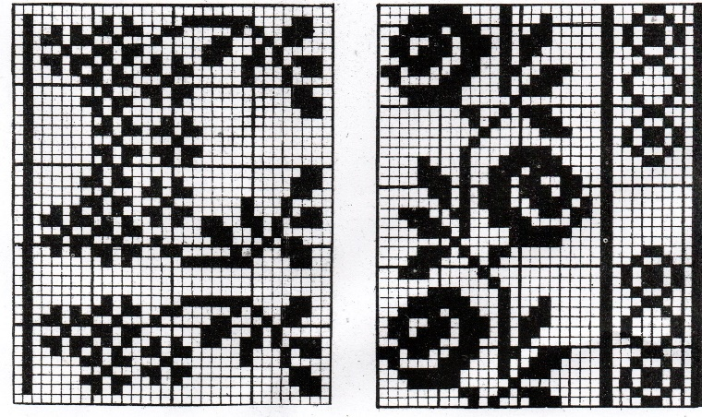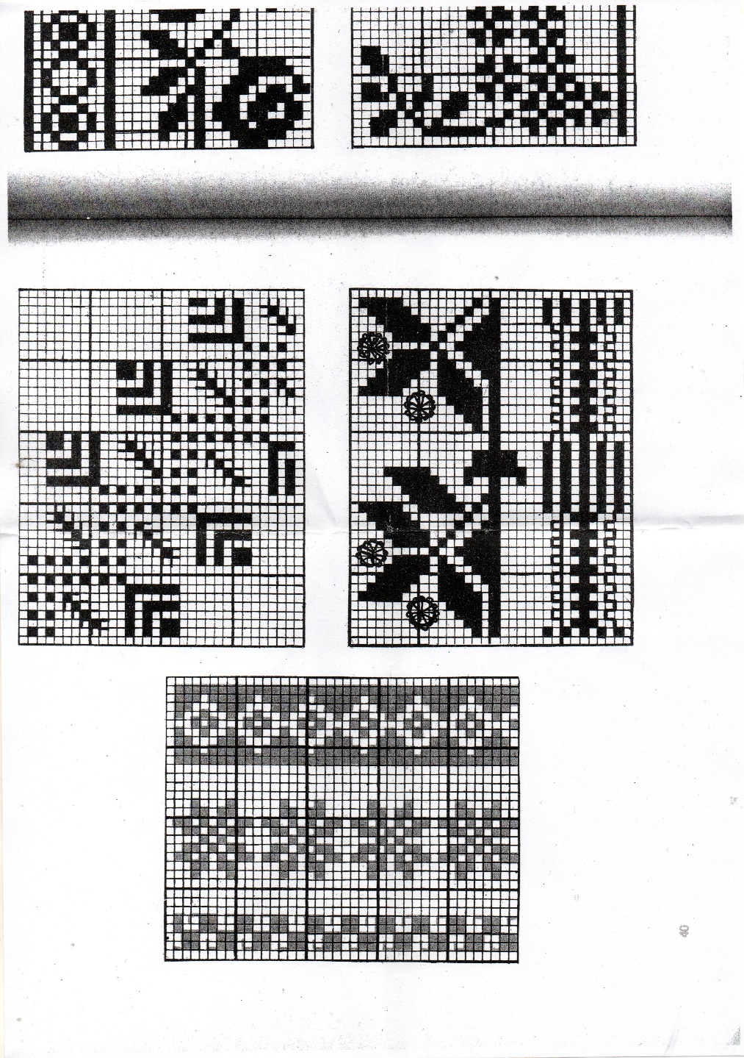
M5
M4
M1
M3
M2
Figure 1. A piece of tablecloth Figure 2. A piece of tapestry Figure 3. A npiece of bed cover
4. We choose the desired motifs: M1, M2, M3, M4, M5.
III. Abstraction:
We transfer the motifs into the drawn algorithm, on stitch rows and steps (stitches). In the following picture, there are 5 examples of traditional motifs:
M5
M4
M3
M2
M1
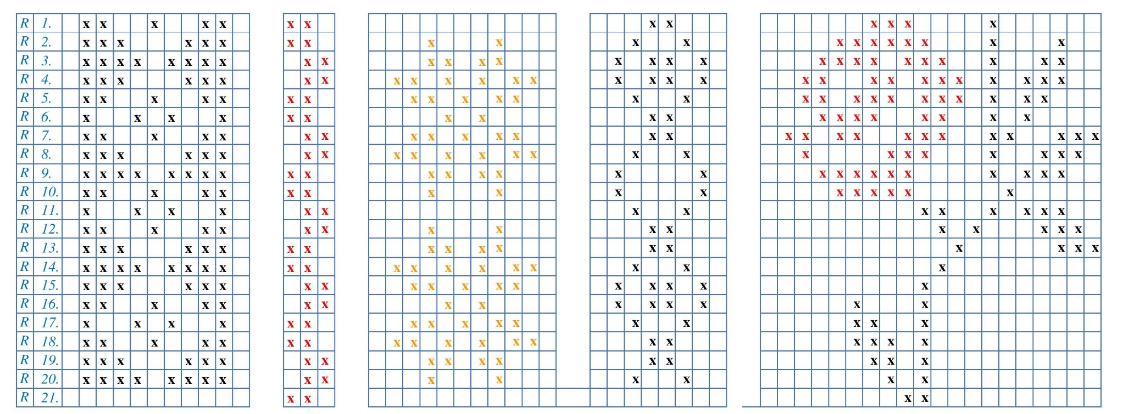

IV. Algorithm design:
Using one of the motifs, we make an object to offer as a gift to someone. We use the technology sheet in Appendix 1.
Example: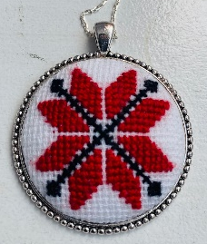

Assessment: |  | Monitoring students’ involvement
Expected results: |  | Students can transfer traditional motifs by sewing and inserting it into an useful object.  Minimal: transfer the motif on canvas.  Maximum: completion of the object.
Notes:
- The importance of traditional patterns, a symbol of national identity, is emphasized.
- The importance of the use of natural materials but also of the specific decor is emphasized.
- Using the mental map helps students to compress and view information more easily.

TECHNOLOGICAL SHEET
1. Product name: Pendant
2. Materials needed:
a) essential materials: etamine 10 cm x10 cm, coloured thread, base for pendant holder.
b) additional materials needed: sewing needle, needle threader, unthreader, pencil, scissors, silicone glue,
3. Draft: it is a drawing done by "hand" and which is in proportion to the real dimensions of the object represented, dimensions that are visually appreciated. The stages of sketching a product are:
a) Studying the object to be drawn. This stage includes establishing the position of operation, identifying the simple geometric shapes and motifs that make up the object, establishing the position of representation, including shape and dimensional details.
b) Designing the draft. At this stage, the logical sequence of operations required to produce the draft is followed: drawing the traditional motif on squared paper using dots.
3. Technological development of the product:
a) The transfer of the traditional motifs, on canvas.
b) Designing the pattern: measuring the circumference of the pendant, drawing the auxiliary line for the pattern, comparing it with the template, then cutting the piece of canvas with sewing.
c) Finishing the pendant: the piece of canvas is fixed with silicone glue on the template and both in the metal base. The pendant is tightened and left to dry.
4. Quality check: checking that each operation has been carried out correctly, the quality of the stitching, its completion and the overall aspect of the pendant.
5. Packaging: in individual bags or in small boxes, including string or ribbon for hanging around the neck or hand.
6. Product promotion: the product can be advertised in catalogues, displayed in shop windows or offered at events.

According to the syllabus "Technological education and practical skills”, grades 5 to 8", approved by order of the Minister of National Education No 3393 of 28 February 2017;
Idem
The technological sheet is the technical document which specifies the name of the product, its characteristics, the materials from which it is made, the product drawing, the sequence of technological operations to be carried out, the tools and instruments used in their execution, the occupational health and safety rules to be followed during the execution of each technological operation and the way in which quality control is carried out.

